

***German Jordanian University***

***Department of Communication Engineering***

***Analog Communication Systems Lab***

***CME 312-Lab***

***Experiment 1***

***Introduction Laboratory Equipments***

***Eng. Anas Alashqar***

***Dr. Ala' Khalifeh***

**Experiment1**

**Introduction to Laboratory Equipments**

***Objectives:***

1. Explore the features and capabilities of the oscilloscope and spectrum analyzer
2. Learn the various components and conventions of the lab equipment from TIMS
3. Use the data sheets to learn about the operation, parameters and limitations of system modules.
4. Perform basic modeling using TIMS

***Introduction:***

***TIMS Overview***

TIMS is a **T**elecommunications **I**nstructional **M**odeling **S**ystem that models block diagrams representing telecommunications systems. Physically, TIMS is a dual rack system; the upper rack accepts up to 12 plug-in cards, or modules; the lower rack houses a number of fixed modules, as well as the system power supply.



Modules

Fixed Modules

Plug-in Modules

**Figure 2** TIMS System Unit

The modules are simple electronic circuits, which serve as basic communications building blocks. Each module, fixed or plug-in, has a specific function; functions fall into three categories:

1. Signal Generation Modules, which provide input/test, signal for the system such as oscillators, variable DC, etc.

2. Signal Processing Modules, which allow you to apply basic signal processing such as adder, multipliers, filters, etc.

3. Signal Measurement Modules, which give you the ability to check and measure the input/output of any stage of the system. Examples include frequency counter, scope selector, etc.

Some of those modules are classified as **basic modules** while others are **advanced modules**. The fixed modules are all basic. Some of the available modules are shown in table 1.

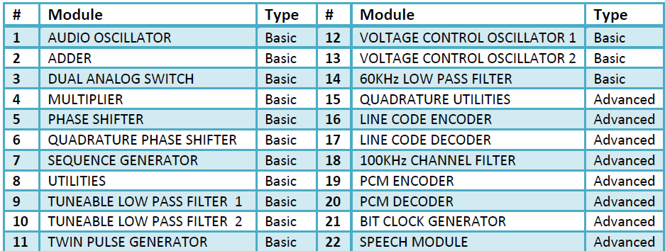

**Table 1** List of the basic and advanced modules

A data sheet for each module describing its input(s), output(s), configurable parameters and function can be found in the *User Manuals* (*Basic* and *Advanced*) available as hard and soft copies.

All TIMS modules conform to the following convention:

• Signal interconnections are made via the front panel sockets.

• Sockets on the left hand side are for module inputs.

• Sockets on the right hand side are for module outputs.

• Yellow sockets are for analog signals.

• Red sockets are for digital signals.

• Analog signals are held near the level of 4V p-p.

• Digital signals are TTL level, (0 to 5 V).

• The green socket is the system ground.

• Any plug-in module may be placed in any of the 12 positions of the upper rack.

• All modules use the back plane bus to obtain power supply.

• The modules can be plugged-in or removed without turning off the power.

***LAB Work:***

This experiment assumes no prior knowledge of telecommunications. You will learn some experimental skills and techniques. It will serve to introduce you to the TIMS system, and prepare you for the more advanced experiments.

***Modules:***

The following plug-in modules will be needed to run this experiment: Audio Oscillator, Adder.

***Procedure:***

**Skill 1: Using Frequency Counter:**

1. Use the Frequency Counter module to verify the frequencies of the following four signals from the **Master Signal: 100 KHz sine, 8.3 KHz Clock, 2 KHz TTL and 2 KHz sinusoid.**
2. Patch lead from output of Audio Oscillator to the analog input of Frequency counter.
3. Using the knob on the front panel of the Audio Oscillator to set the frequency to approximately 1 kHz**.**

**Skill 2: Using Scope Selector**

1. Use the coaxial connectors to connect **CH1** and **CH2** of Scope Selector with **CH1** and **CH2** of the PicoScope, respectively.
2. Patch lead from output of 2 KHz message to the **CH1-A** input of the scope selector.
3. Patch lead from output of 100 KHz sine carrier to the **CH2-A** input of the scope Selector.
4. Using dual mode channel of the PicoScope to compare between the two signals.
5. Use the PicoScope to measure the frequency and the peak voltage for the two signals.

**Skill 3: Generating Sinusoidal Message Signal**

***Note:***

To generate any sinusoidal message signal we have to use **Audio oscillator** module to set the proper frequency and **Buffer Amplifier** to set the proper Amplitude.

1. Patch lead from **sin(ɷt)** output of Audio Oscillator to the **A** input of the Buffer Amplifier.
2. Patch lead from **k1, A** output of Buffer Amplifier to the **CH1-A** input of the Scope Selector.
3. Using the knob on the front panel of the Audio Oscillator set the frequency of the signal that displayed on **CH1** of the PicoScope, to approximately 5 kHz.
4. Adjust the **k1** gain control of the Buffer Amplifier until the signal displayed on **CH1** of the oscilloscope, is about 4-volt peak-to-peak.
5. Save the signal in your lab sheets

***Note:***

We can also set the Amplitude of the signal using **Adder Module,** which will be done in next steps.

1. Patch lead from **sin(ɷt)** output of Audio Oscillator to the A input of the Adder.
2. Patch lead from output of Adder to the **CH2-A** input of the Scope Selector.
3. Adjust the G gain control of the Adder until the signal displayed on CH2 of the oscilloscope, is about 4-volt peak-to-peak.
4. Compare between the two signals in CH1and CH2 of the PicoScope.

**Skills 4: Finding Signal Spectrum**

1. Connect **CH1** of Scope Selector with **CHA** of the PicoScope.
2. Patch lead from output of 2KHz message signal to the **CH1-A** input of the scope selector.
3. Save the signal in your lab sheets.

**Skills 6: Modeling Mathematical Equation**

***Note:***

Any mathematical equation can be implemented using TIMS's true hardware modeling approach as shown below:

**1. Take a mathematical equation:**

Y(t)=1+0.5Cos(2000πt)

**2- Draw block diagram to represent the Equation:**

+

**1**

**Cos( 2π $f_{1}t$** )

**Y(t)**

**Figure.1** Block diagram approach of Equation (1)

**4- Implement it using TIMS Modules**

1. Using frequency counter set the Audio Oscillator frequency about 1kHz.
2. Patch the Audio Oscillator with adder then set the adder gain 'g' to 0.5
3. To set the other Gain Value of the other you have to remove the lead of the Audio Oscillator.
4. Patch the variable DC Module with adder then set the adder gain 'G' to 0.5 Using DMM.
5. Finally, reconnect the Audio Oscillator with the adder. (see figure 2)

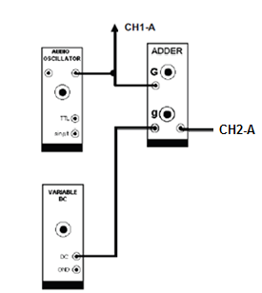

**Figure.2** The TIMS model of the block diagram of Figure 1**.**

1. Save the waveform of input signal Y(t) using the PicoScope in your lab sheets.
2. Save the spectrum of input signal Y(t) using the PicoScope in your lab sheets.