Lab. 6: The Bipolar Junction Transistor (BJT)DC Bias Stabilization
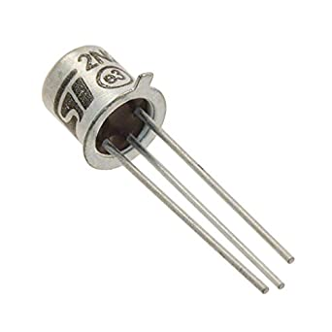
Part 1 :- Simulate the following circuit and fill the table below (you have to add screen shot of your simulator result ): -
R1 = 120kΩ, R2 =120kΩ, R3 =6.8kΩ use BJT 2N2222 , consider β=75
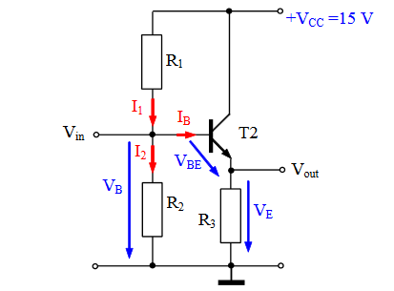

V_{B} /V | V_{E} /V | V_{C} /V | I_{E} | I_{C} | I_{B}
 |  |  |  |  |  | Simulation result
 |  |  |  |  |  | Calculation

Measure:-
V_{BE}/V | V_{BC}/V | V_{CE}/V | V_{R1} | V_{R2}

The transistor work :-
- In active region
- At saturation point
- At cut-off point
Why ???

Part 2:-
- Change R1 from 120k to 10k then measure
V_{B} | V_{C} | V_{E}

The transistor work :-
- In active region
- At saturation point
- At cut-off point
Why ???

- Change R2 from 120k to 3.3k then measure
V_{B} | V_{C} | V_{E}

The transistor work :-
- In active region
- At saturation point
- At cut-off point
Why ???

Part 3:
Temperature effect on bias stability and stability factor %ΔIc.(to be discussed in online session)

Typical transistor parameters affected strongly by temperature are turn on voltage (Vbe-on for bipolar=), turn-off leakage current, current gain.
For bipolar transistors with increasing temperature:
- Vbe decreases
- Current gain ẞ increases

